Introduction

We have tried to keep the documentation small, interesting and effective. So through out the documentation we will show step by step how to customize this game to give a total different look, how to brand your company via this game, how to set up for your admob etc. But still if you have further query then you can send us an email. It will be our pleasure to help you to build an awesome product.   
  
(Please Note: This game was developed in Free version of Unity Game Engine (version Unity 2019.1.6f ). If you do not have this engine installed please download and install it to follow along different steps. It’s absolutely free and you can download it from [Here](https://public-cdn.cloud.unity3d.com/hub/prod/UnityHubSetup.exe?_ga=2.2422192.1034359112.1562946794-336589068.1557846566&_gac=1.211944736.1562037300.EAIaIQobChMIgZv1pqKV4wIVR8q9Ch1lQwluEAEYASAAEgLFHPD_BwE) ).

### Giving Your Game an Awesome Name And Logo

It's very easy if you want to change the default game name (‘REAL STACK’) and give a cool name to your game. Open the project with Unity and click on the ' Assets /Scenes' folder as shown in the following image. In this folder you will find different unity scenes which are basically different screens of your game. First screen was named as ' Menu ' (as you can see in the following image), so double click on it to open the scene. Now at the right Hierarchy you will find Canvas / ‘YourGameName’. From here change the game name as indicated in the image.

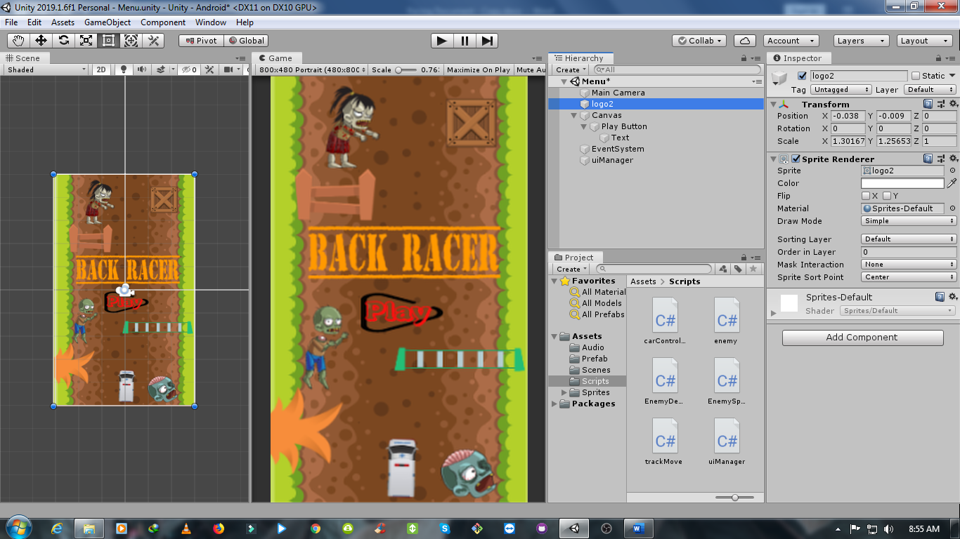

### Branding Your Company

It’s time for branding your company. This process is very similar as the previous step. On the same scene as above under Canvas find 'YourCompanyName'. Give your own company name as shown in the instruction image below.

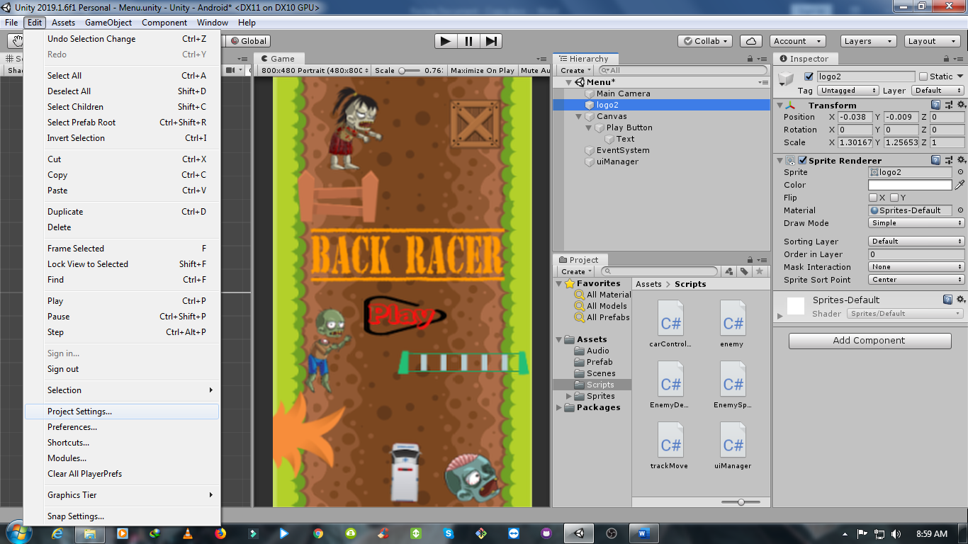

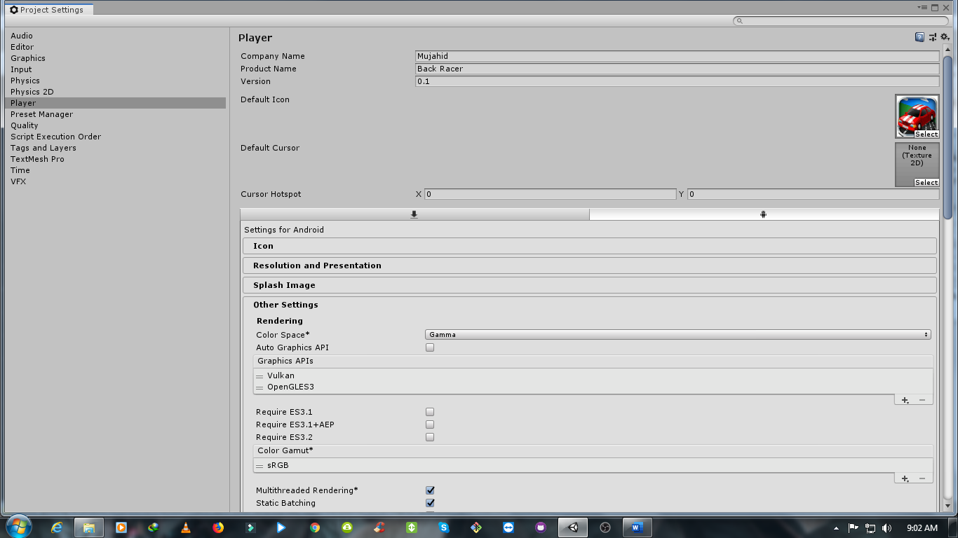

### Giving a Different Look to your Game

Let’s change some content of the game world to give it a different look. As we have said earlier that each of your screens have been arranged in different scenes and kept in ' Assets / Scenes ' folder. Select the scene named as 'Game'. Here for example let's say you want to change the Color.

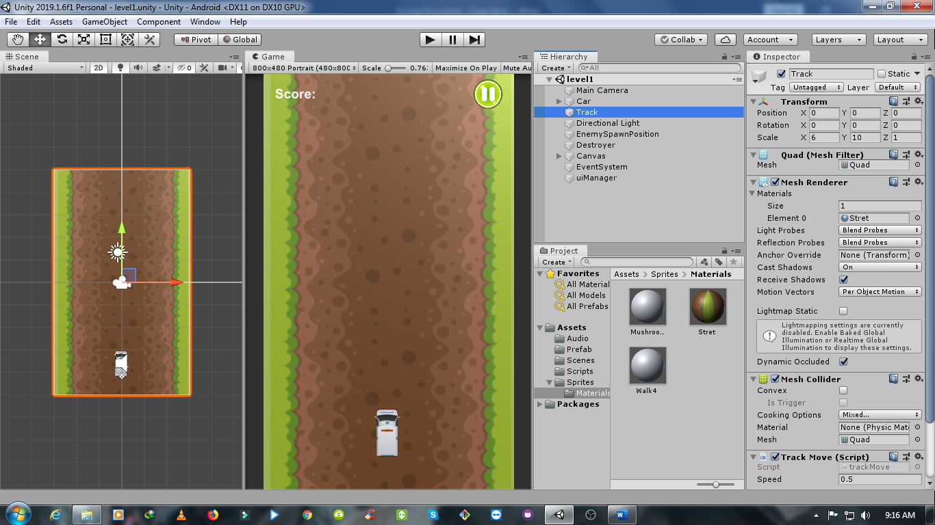

### Publishing for Android/ iOS/Windows Phone/BlackBerry/Web

As this game is developed in Unity Game Engine, you can build for several platforms (android, iOS etc. ) from this single project. Click on File and then 'Build Setting' to get the following window. Switch to the appropriate platform and hit Build. However there are a lot of tutorial for publishing the signed app on Google Play store or App Store. Following are some of such useful links that you can visit in case you face any problem.

[How to Submit your game to the iOS App Store - Unity Official Tutorials](https://www.youtube.com/watch?v=C3izqF6h_aY)

[Publishing Unity Game on Google Play Store](https://www.youtube.com/watch?v=qFS77pQ2VaQ)

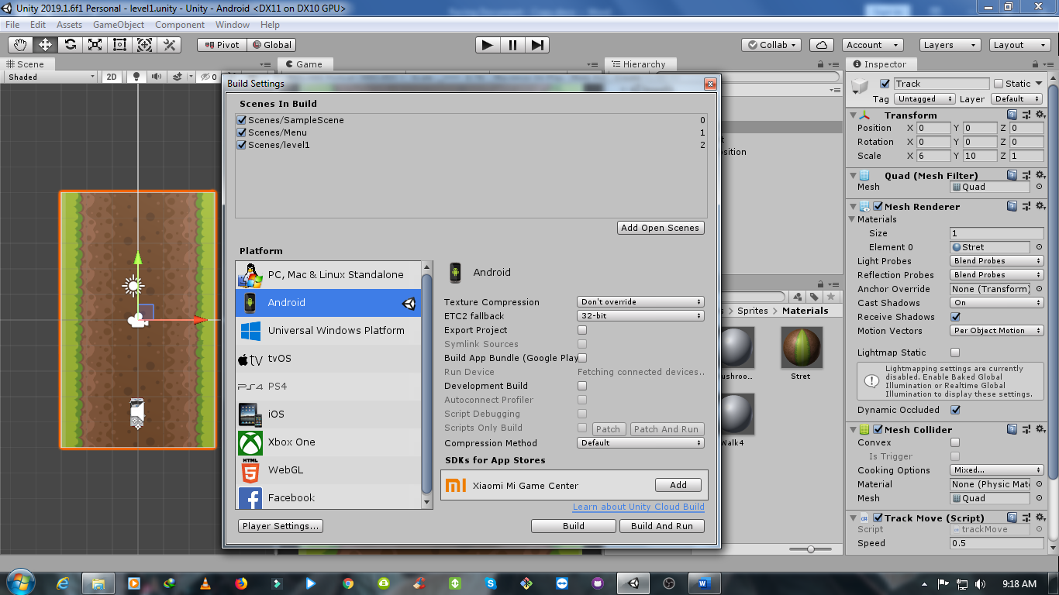

Conclusion

Hope the steps shown were helpful to you. However if you still face any problem with any of those steps or you have any other confusion please feel free to contact us. We will be always happy to help you. You can send us mail at ( ) for faster response. Thanks and Good Luck.